Registration for 2018-19 School Year
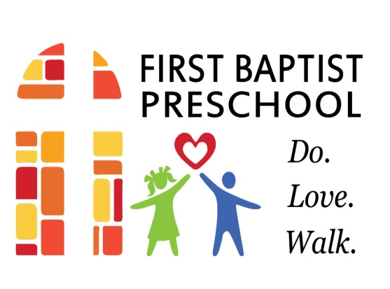
First Baptist Church Weekday Preschool
301 S. Wayne Avenue
Waynesboro, VA 22980

CLASS: (check one) ____ 2 Year Old Class (T/Th) Tuition $110/month or $990 per year
____ 3 Year Old Class (M/W/F) Tuition $135/month or $1,215 per year
____ 3 Year Old Class (M-F) Tuition $165/month or $1,485 per year
____ 4 Year Old Class/PreK (M-F) Tuition $165/month or $1,485 per year

Child’s Name: (first)________________________(middle)________________________(last)_______________________
Preferred Name: ________________________________
Gender (circle one): male female
Date of Birth: ___________________________________
Address: _________________________________________________________________________________________________
Previous School(s) Attended: __________________________________________________________________________

Parent/Guardian Contact Information
Mother/Guardian: _______________________________ Father/Guardian: __________________________________
Address: ________________________________________ Address: ____________________________________________
__________________________________________________ ______________________________________________________
Primary Phone: ________________________________ Primary Phone: ____________________________________
E-mail: ____________________ _____________________ E-mail: ______________________________________________
Place of Employment: _________________________ Place of Employment: _____________________________
Work Phone: ___________________________________ Work Phone: ________________________________________

Does your child have any needs that may require special care? If yes, please explain. ____________________________________________________________________________________________________________
____________________________________________________________________________________________________________
Does your child currently receive or has your child ever received Early Intervention and/or Special Education services? If yes, please explain. ___________________________________________________________________________________________________________
___________________________________________________________________________________________________________
TO COMPLETE THE ENROLLMENT PROCESS, YOU WILL NEED TO PROVIDE A CURRENT SIGNED AND DATED IMMUNIZATION RECORD FROM YOUR CHILD’S HEALTHCARE PROVIDER AND AN ORIGINAL OR CERTIFIED COPY OF YOUR CHILD’S BIRTH CERTIFICATE.

Signature of Parent: _____________________________________________ Date: ____________________________
____________________________________________________________________________________________________________
A non-refundable registration fee is required at the time of registration.
Registration fees are as follows: $50 to register one child
$40 to register an additional child
$40 to register a child if First Baptist Church member

For Office Use Only
Date Received__________________________
Check #____________ Cash ________
Amount Paid ___________________________

Immunization Record On File ___________
Birth Certificate Reviewed _____________

